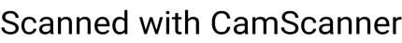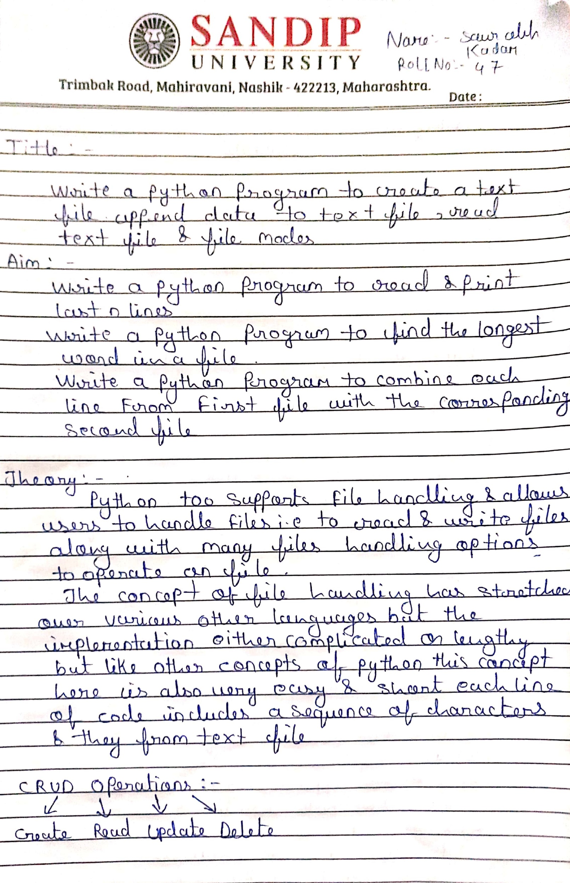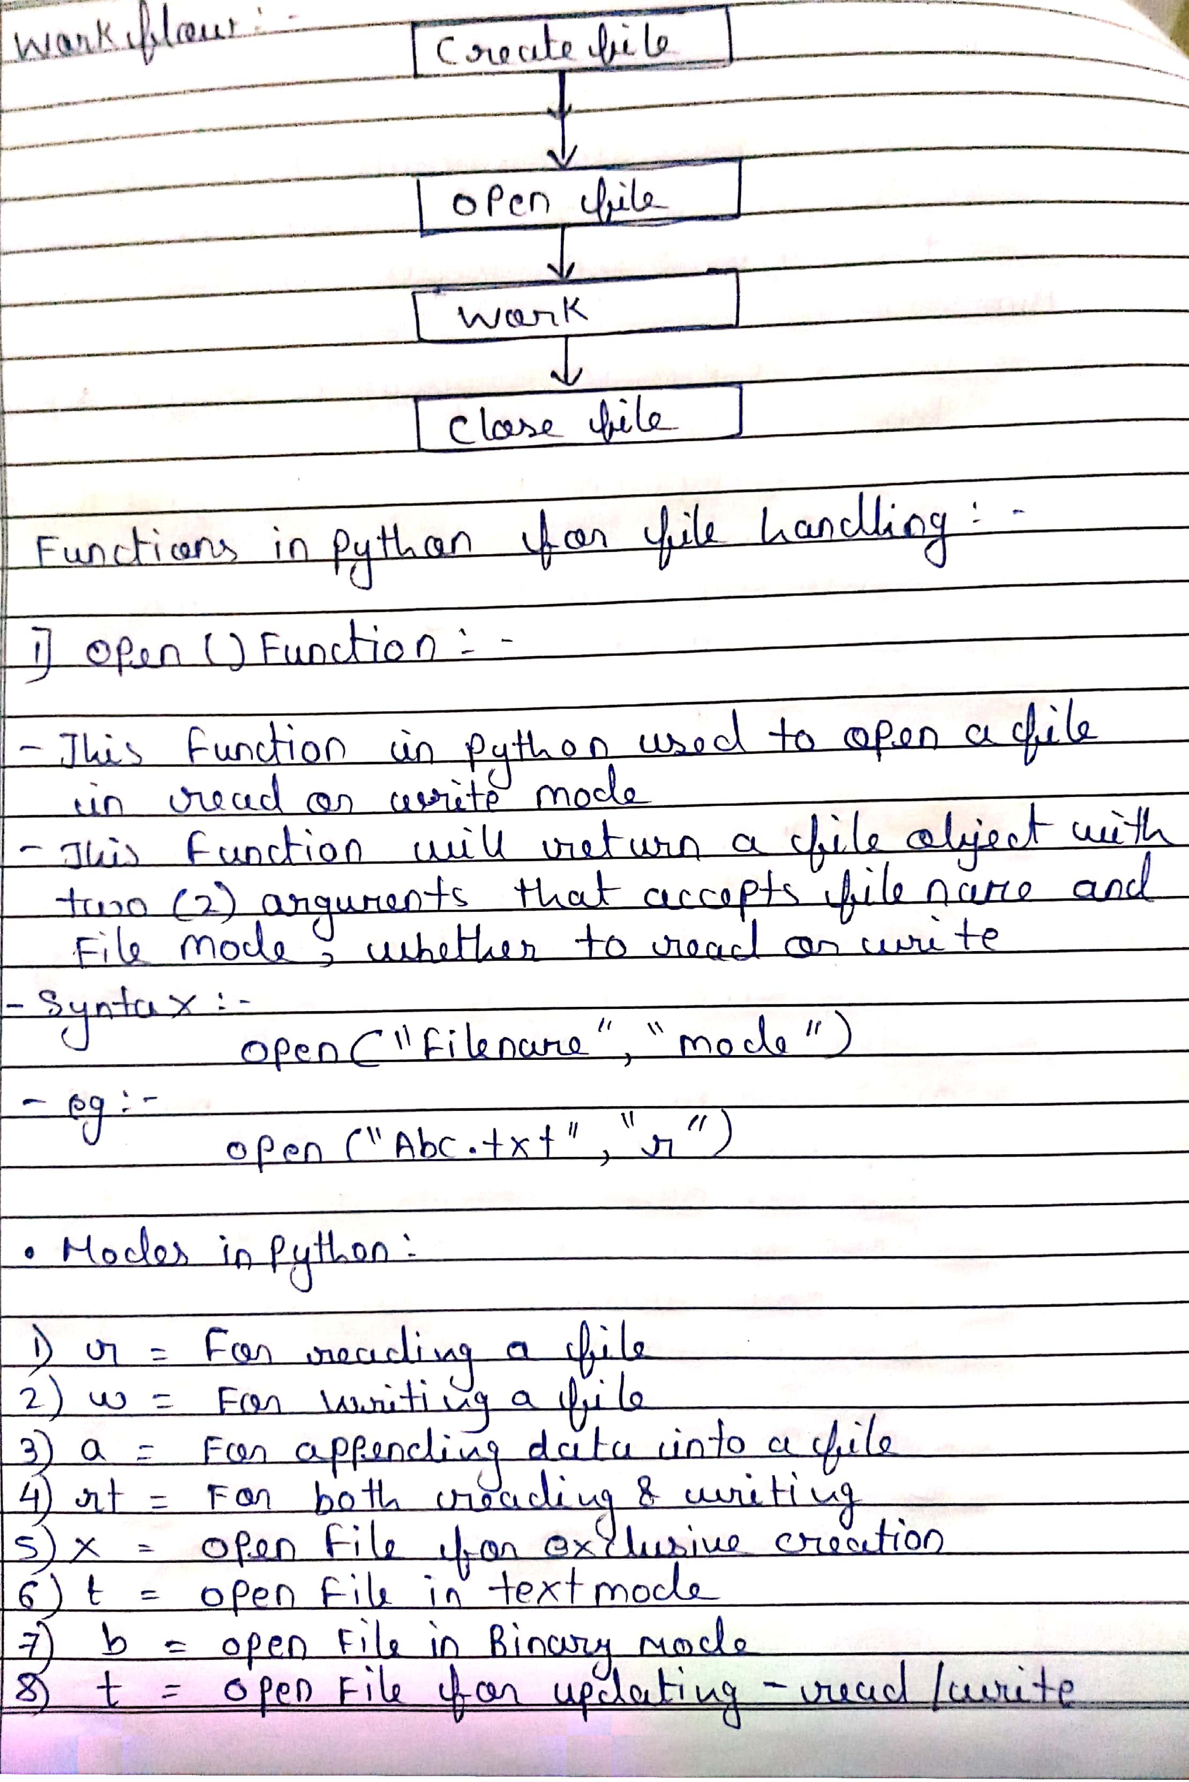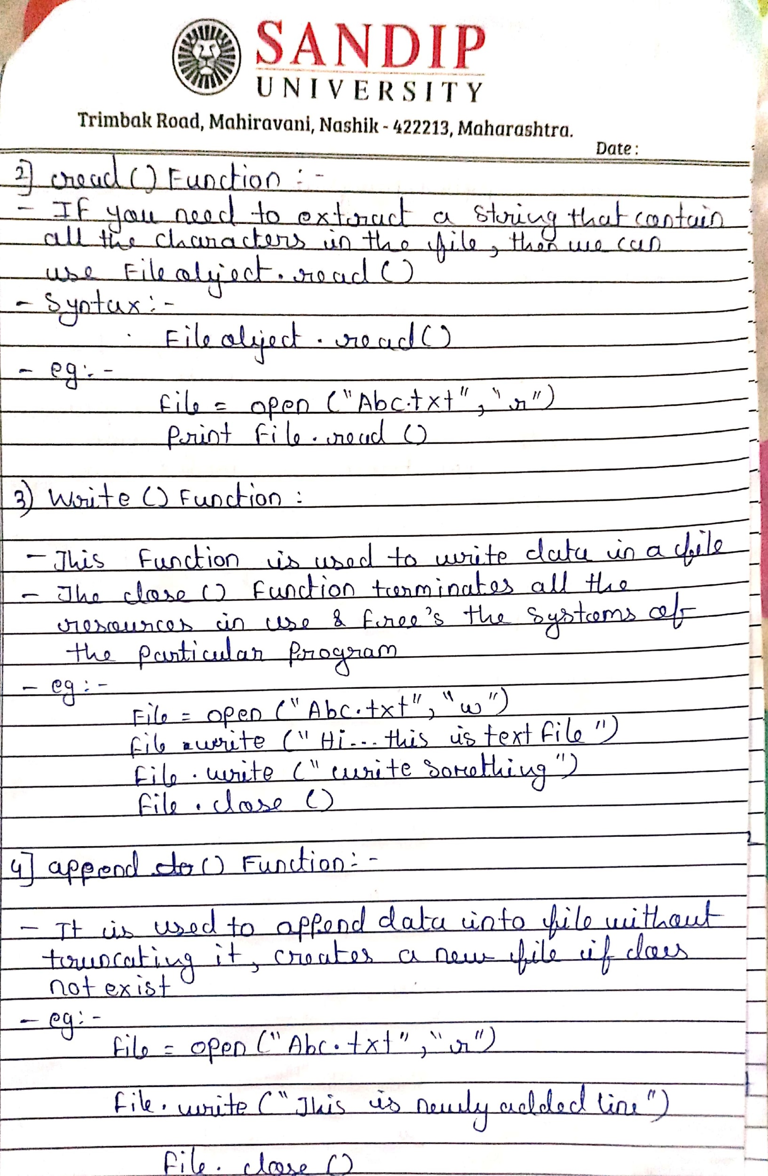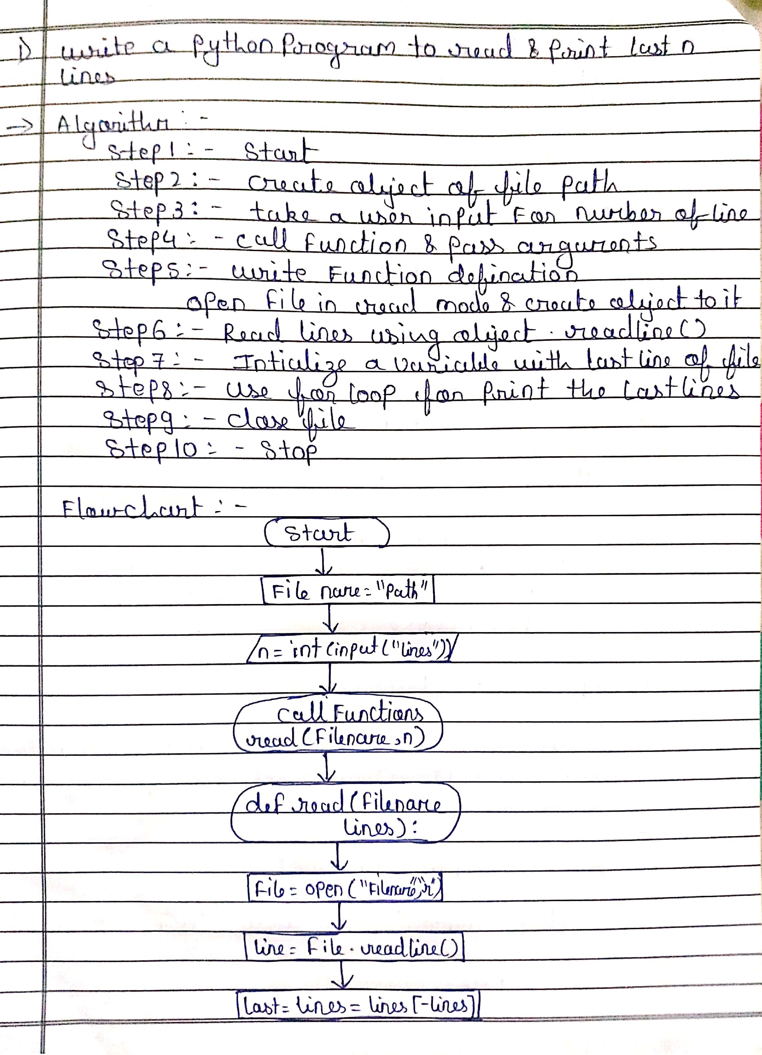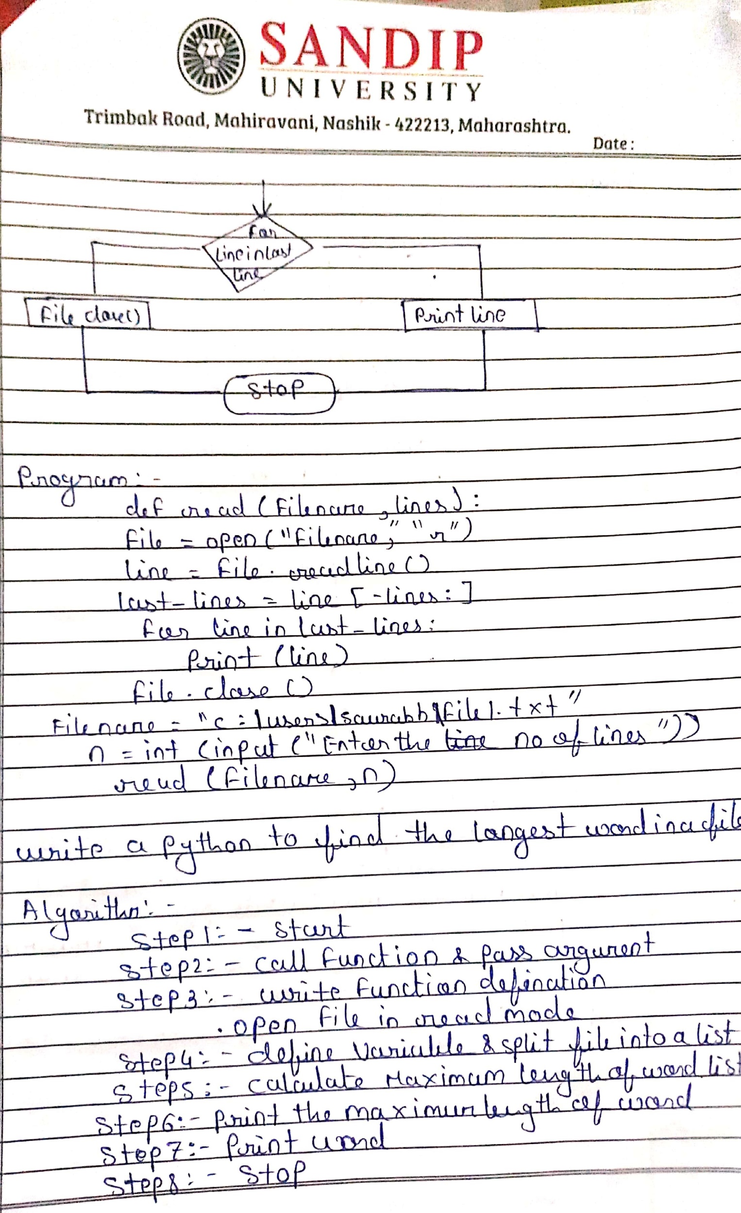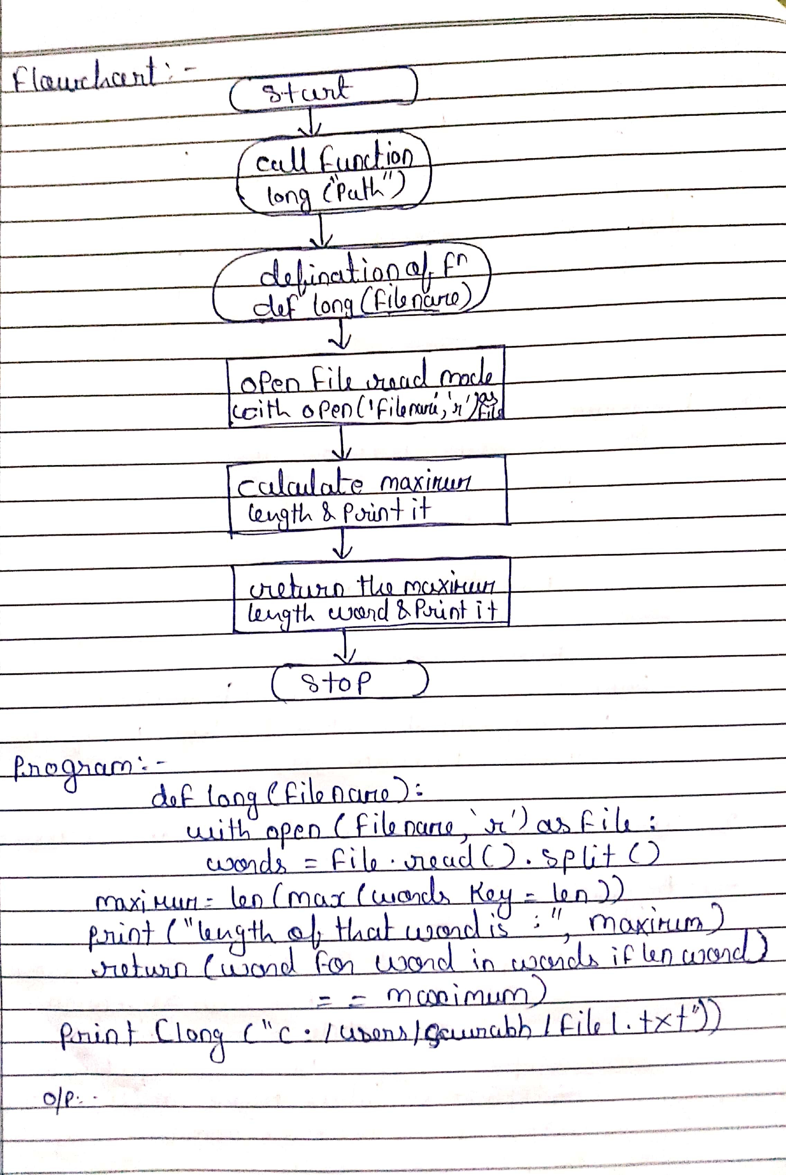

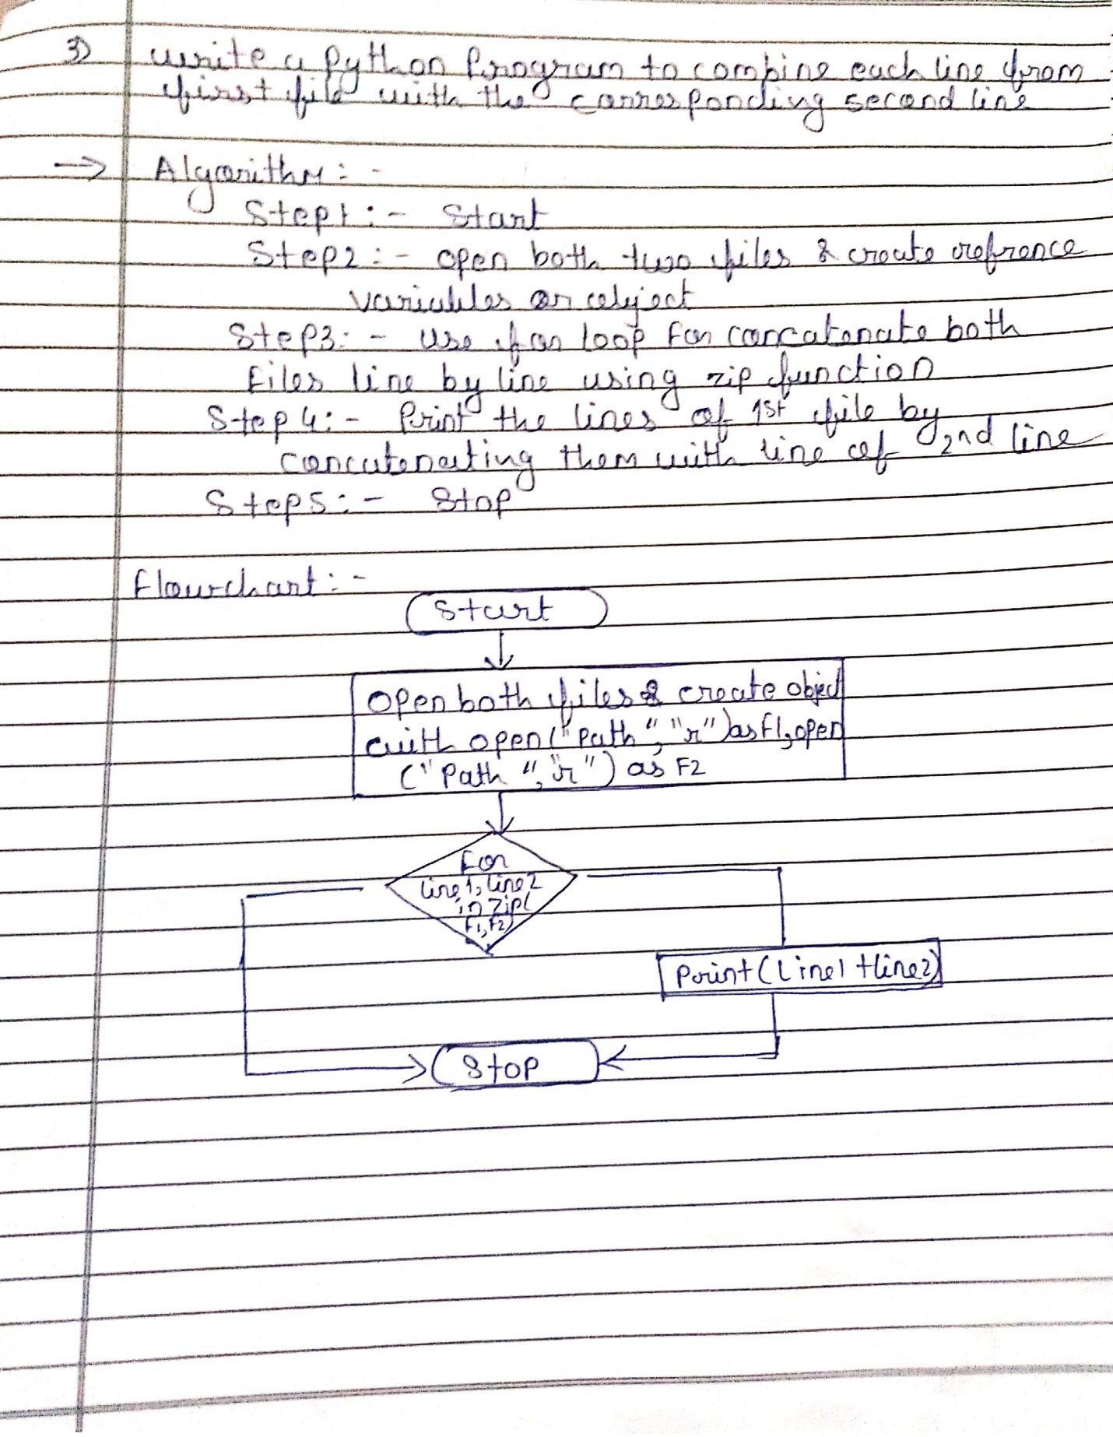

#WAP to read last n lines of file

**PROGRAM:**

def main():

file=open("F:/Data/test.txt","r")

print(file.readlines()[-5:])

if __name__ =='__main__':

main()

**OUTPUT:**

['Web development\n', 'Scientific programming\n', 'Desktop GUIs applications\n', 'Network programming\n', 'Game programming.']

Process finished with exit code 0

#WAP to find a longest word and count of that word in file

**PROGRAM:**

def longest_words(filename):

with open(filename, 'r') as infile:

words = infile.read().split()

max_len = len(max(words, key=len))

print("Length of longest word: ",max_len)

return [word for word in words if len(word) == max_len]

print(longest_words('F:/Data/test.txt'))

**OUTPUT:**

Length of longest word: 13

['optimization.']

Process finished with exit code 0

#WAP to combine each line from first file with the corresponding line in second file.

**PROGRAM:**

with open('F:/Data/test2.txt') as fh1, open('F:/Data/test.txt') as fh2:

for line1, line2 in zip(fh1, fh2):

print(line1+line2)

**OUTPUT:**

Python is an easy to learn, powerful programming language.

Python is an open source programming language that was made to be easy-to-read and powerful.

It has efficient high-level data structures and a simple but effective approach to object-oriented programming.

Python is an interpreted language.

Pythonâ€™s elegant syntax and dynamic typing.

Interpreted languages do not need to be compiled to run

together with its interpreted nature.

Python is a good programming language for beginners.

make it an ideal language for scripting and rapid application development in many areas on most platforms.

Python drew inspiration from other programming languages like C, C++, Java, Perl, and Lisp.

The Python interpreter and the extensive standard library are freely available in source or binary form for all major platforms from the Python Web site.

Python's developers strive to avoid premature optimization.

https://www.python.org/.

Cython is also available.

and may be freely distributed.

Some things that Python is often used for are:

The same site also contains distributions of and pointers to many free third party Python modules.

Web development

programs and tools.

Scientific programming

and additional documentation.

Desktop GUIs applications

Process finished with exit code 0

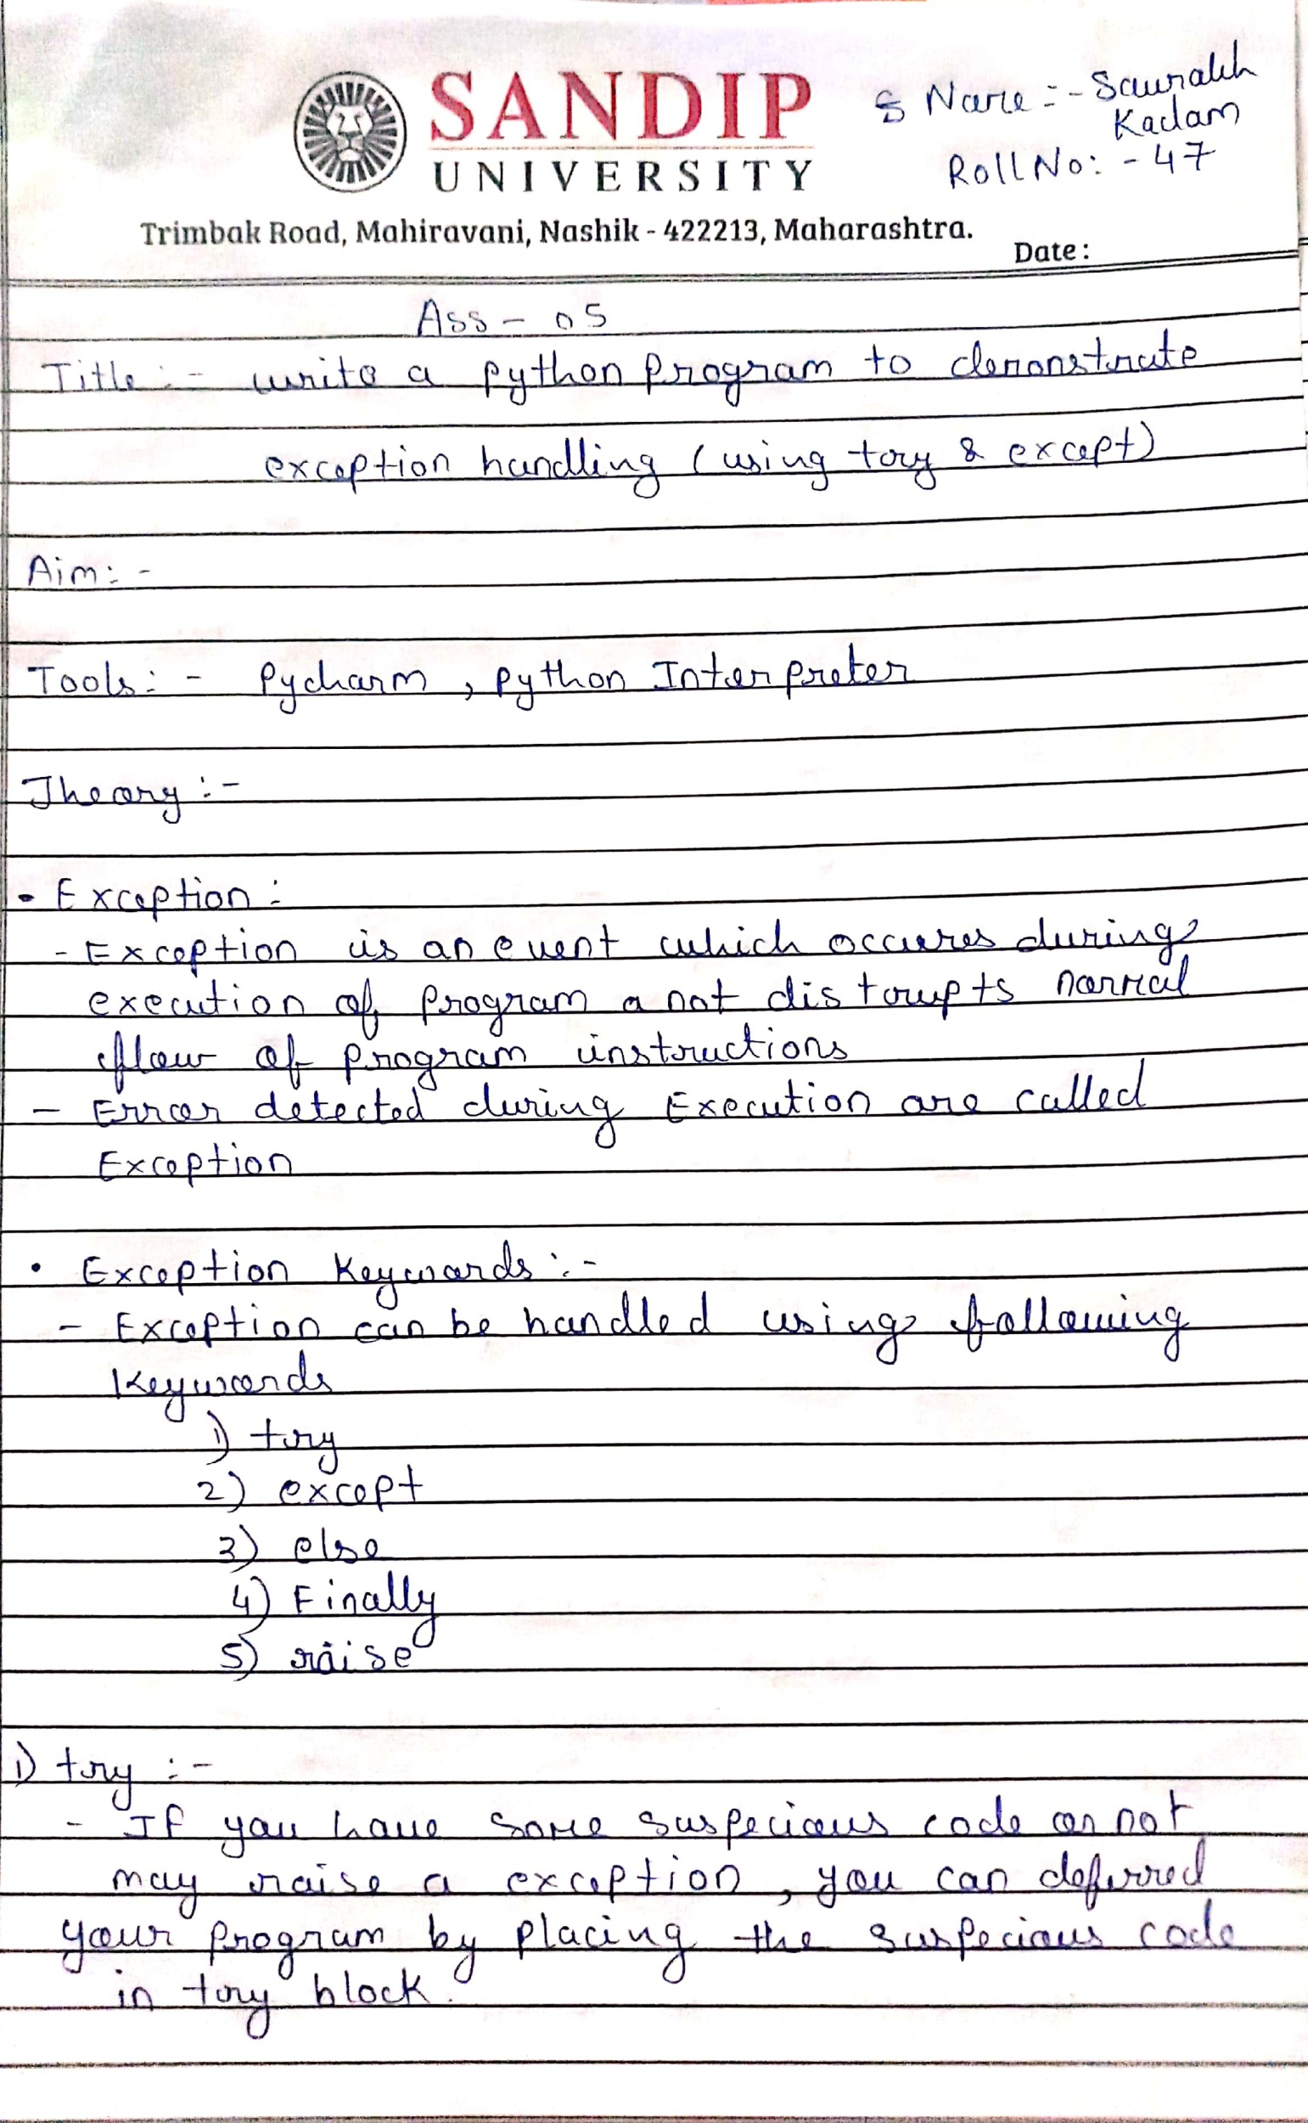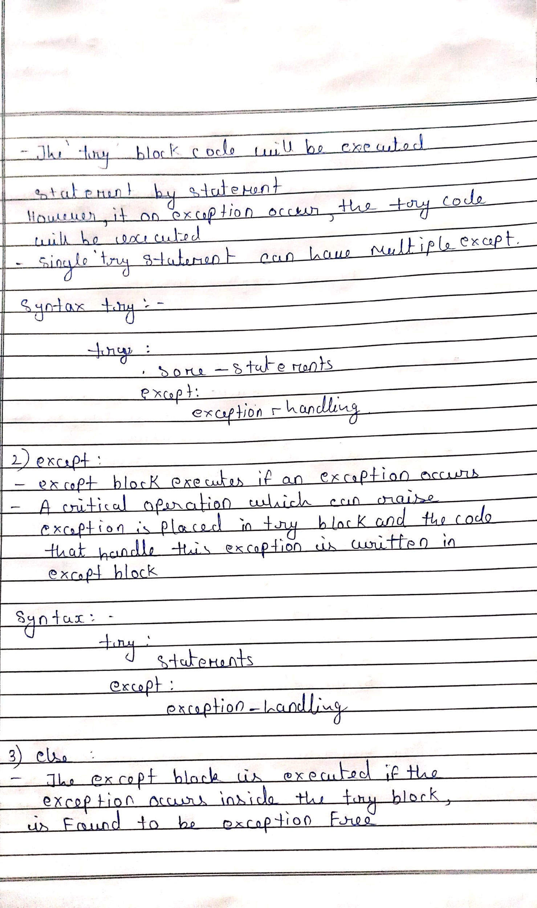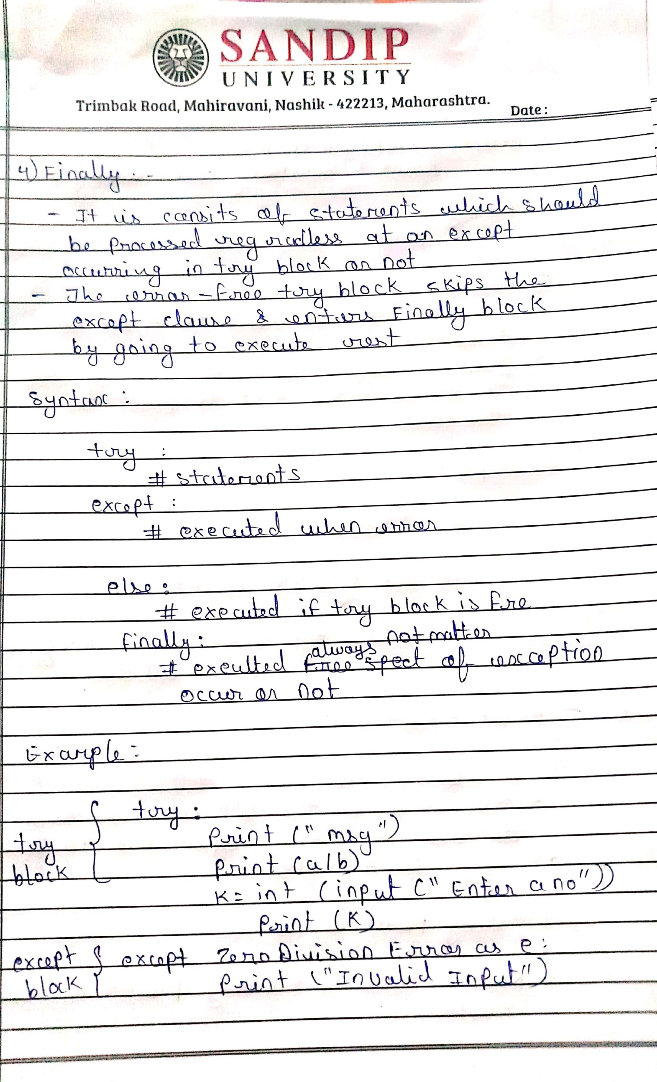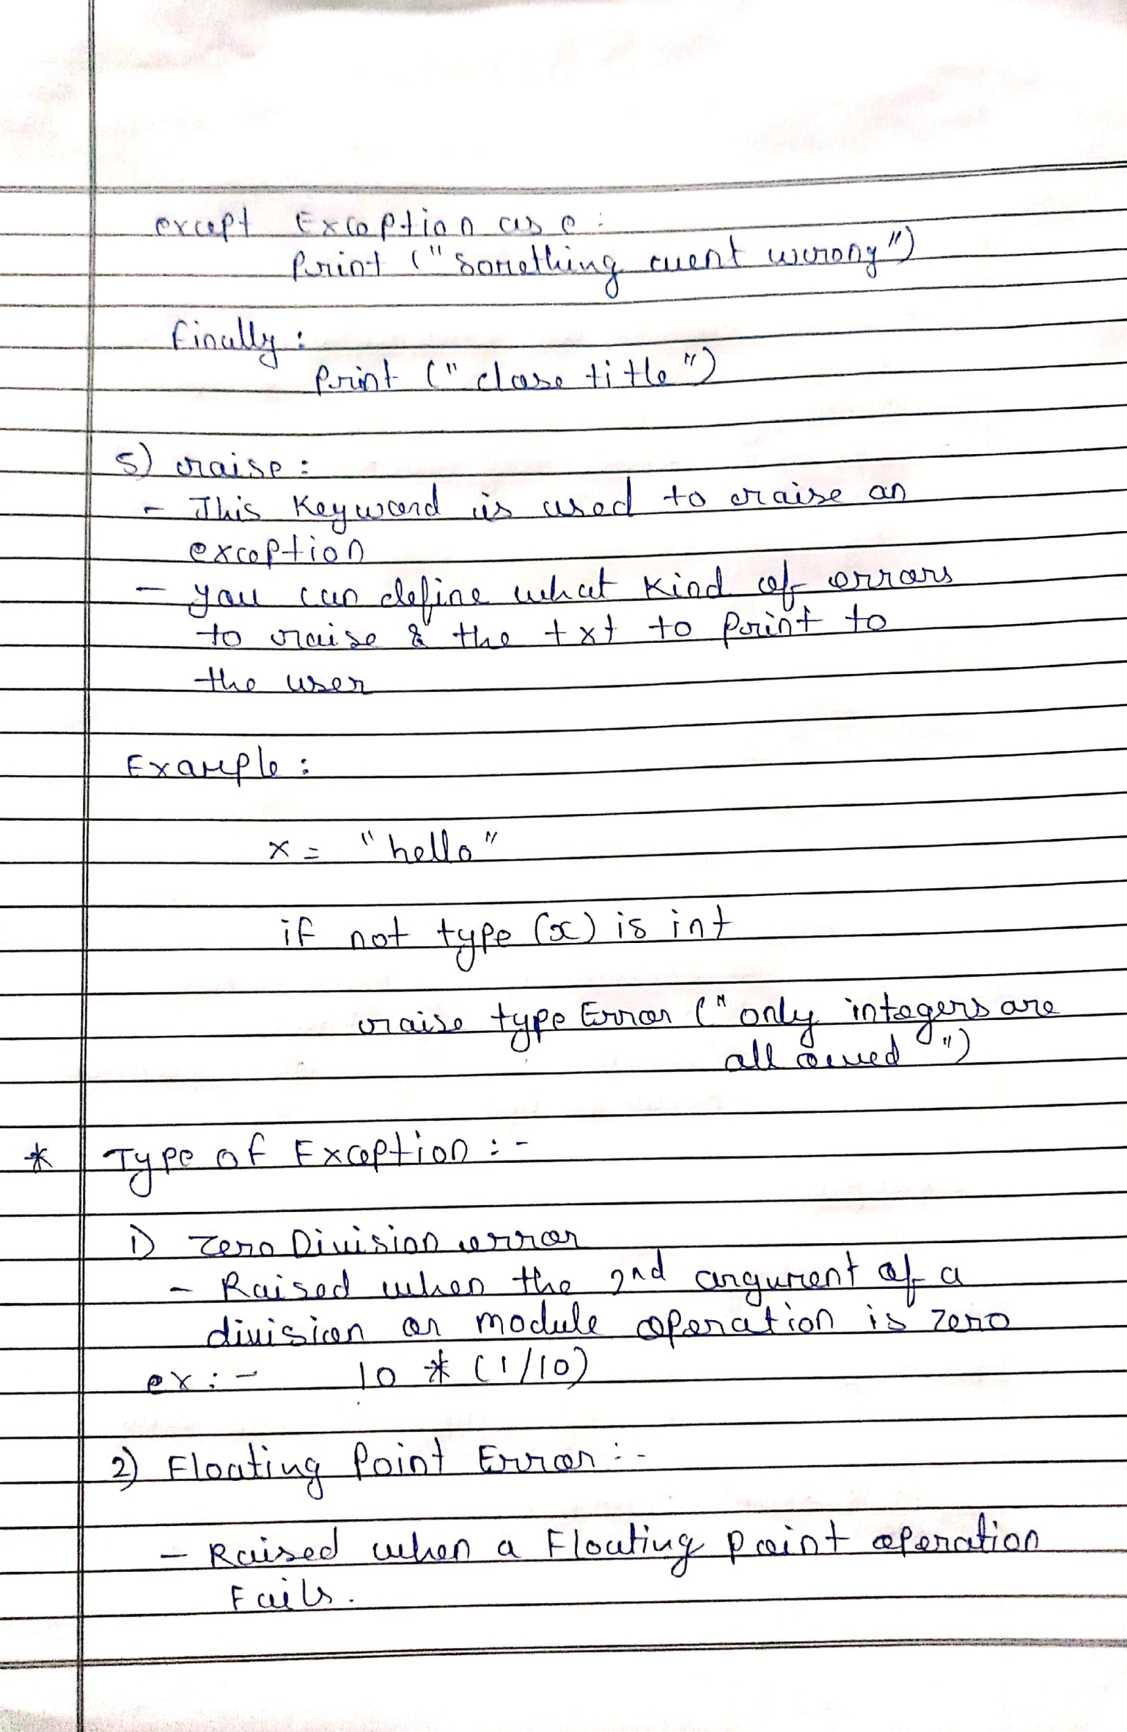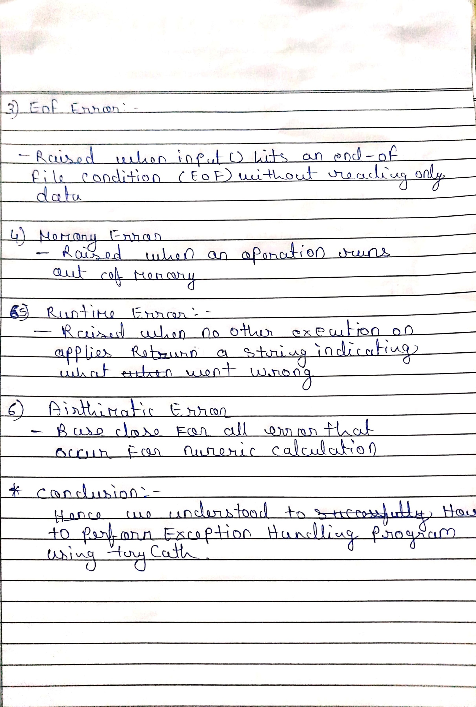

**#WAP to perform Exception Handling Program using Try Catch Block.**

**try**:  
 a = int(input(**"Enter a:"**))  
 b = int(input(**"Enter b:"**))  
 c = a/b  
 print(**"a/b = %d"**%c)  
**except**:  
 print(**"can't divide by zero"**)  
**else**:  
 print(**"Hi I am else block"**)

**o/p:-**

C:\Users\rd\PycharmProjects\clg-projects\venv\Scripts\python.exe C:/Users/rd/PycharmProjects/clg-projects/trycatch.py

Enter a:10

Enter b:0

can't divide by zero

Process finished with exit code 0

**#WAP to perform Exception Handling Program using Try Catch Block and Raise.**

try:  
 age = int(input("Enter the age?"))  
 if age<18:  
 raise ValueError;  
 else:  
 print("the age is valid")  
except ValueError:  
 print("The age is not valid")

**o/p:-**

C:\Users\rd\PycharmProjects\clg-projects\venv\Scripts\python.exe C:/Users/rd/PycharmProjects/clg-projects/trycatch1.py

Enter the age?16

The age is not valid

Process finished with exit code 0

**#WAP to perform Exception Handling Program using Try Catch Block using OOP concepts**

**class** ErrorInCode(Exception):  
 **def** __init__(self, data):  
 self.data = data  
  
 **def** __str__(self):  
 **return** repr(self.data)

**try**:  
 **raise** ErrorInCode(2000)  
**except** ErrorInCode **as** ae:  
 print(**"Received error:"**, ae.data)

**o/p:-**

C:\Users\rd\PycharmProjects\clg-projects\venv\Scripts\python.exe C:/Users/rd/PycharmProjects/clg-projects/TryCatch2.py

Received error: 2000

Process finished with exit code 0